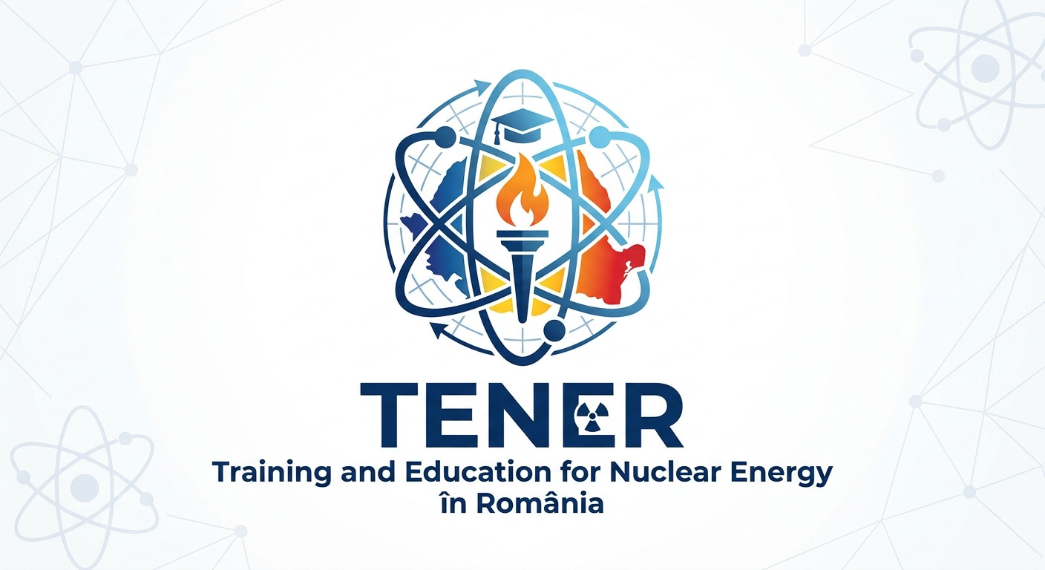

Title, in Title Case
(Each Word of the Title should be Capitalised)
Authors’ names
Authors’ affiliation (Organization, City, Country)
Corresponding author’s e-mail

Please, tick the Conference’s topic you want to participate

- Reactor physics and nuclear safety
- Physics and engineering of nuclear materials
- Applied Chemistry of Nuclear Systems
- Nuclear Facility Engineering
- Robotics and automation in nuclear facilities
- Radioactivity: applications, dosimetry, radiation protection, radioactive waste management
- Vocational training and education for the nuclear field
- Advanced reactors, SMRs and emerging technologies
- Artificial Intelligence and Digital Twin in Nuclear
- Nuclear Photonics
- Nuclear fusion

Also, use the template available on the next page, to write your abstract.

Title, in Title Case
(Each Word of the Title should be Capitalised)
Authors’ names
Authors’ affiliation (Organization, City, Country)
Corresponding author’s e-mail

ABSTRACT
The abstract should contain 200 up to 500 words. It is compulsory to present the purpose, results and conclusions of your original contribution related to the Conference topics.
Authors should not include equations, tables, figures and references in abstract.
Please use this template file to write your abstracts: A4 format with 25 mm margins all around. The text should be written in Arial 12, single spaced, justified, with the first line intended by 10 mm.
Please, submit your abstract via the conference webpage https://conf.anuen.ro/tener/scheduled/2026 by October 30, 2026, naming it according to your family name and conference topic’s number (for example: popescu-topic1.doc).

